Random Forest

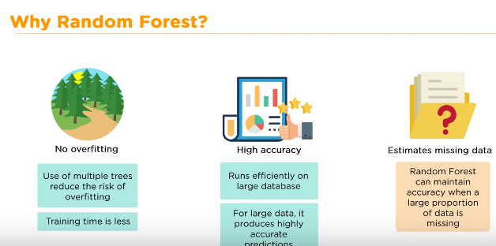

randomState = ensemble.RandomForestClassifier(random_state=42)

// 42 meaning, the values don’t change if executions are repeated